Challenge on Terraform-2
Goal of the Exercise
The goal of this exercise is to test your understanding of a Cloud Compute deployment with Terraform.
You are tasked with creating a codebase for a microservice deployment on a cloud environment, using Terraform. Since our focus is not the application itself, the service will be a simple web server that returns a static page.
Requirements
Service Details
- The service will be a simple web server that returns a static page.
- You can use apache2 or nginx to serve a simple HTML file.
- The service should be containerized and stored in a Docker registry.
- The service should be deployed on a single VM instance as a docker container.
- The image should be pulled from the registry specified earlier.
- The service should not be accessible from the internet but only through a Load Balancer, except for SSH access from specific IP addresses.
Deliverables
You are to provide the following as part of your solution:
- Docker file to build the image.
- Terraform codebase to deploy the following:
  - Docker registry
  - VPC and all required networking resources
  - EC2 instance
  - Load Balancer
Notes
- Since a CI/CD pipeline is not part of this exercise, we will work around that with the help of Terraform.
- To push the image to the Docker registry, build the image locally before running the Terraform code.
- Once the image registry is created, use Terraform to push the local image to the registry.
- Similarly, use Terraform to pull the image from the registry and run it on the VM instance once it is created.
- For SSH access:
  - Use a locally created key.
  - Add it to the cloud provider key storage.
  - Attach it to the instance.
- Use Terraform best practices for file structure and code organization.
  - Use variables, locals, modules, etc. when appropriate.
- Include all tfvars, scripts, and other helper files used to deploy the application.
- You may use any cloud provider of your choosing, although AWS is preferred.
- Use a free tier account or a trial account to deploy the resources.

First I have created a main.tf file
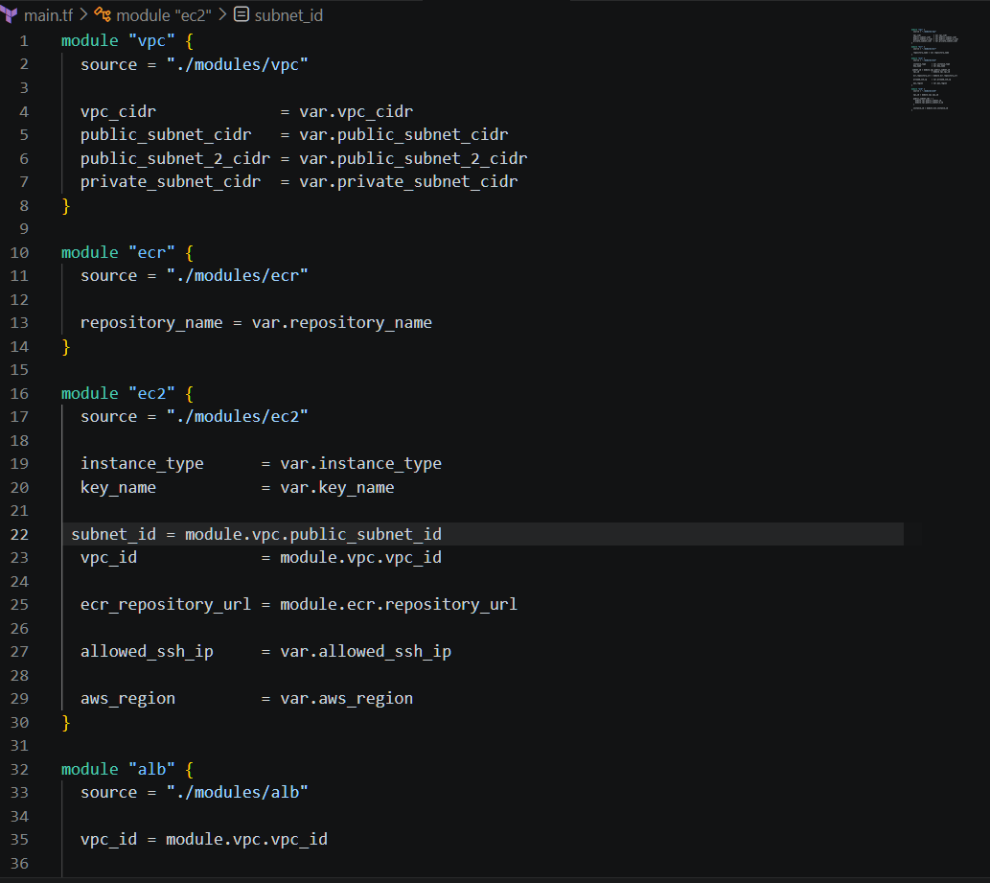
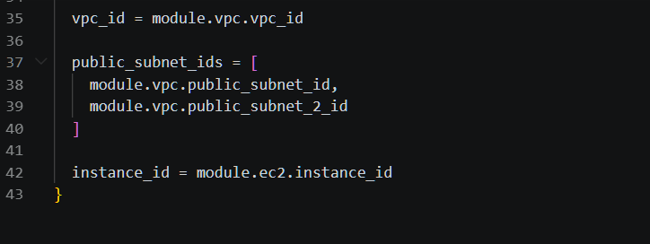

Created Variables.tf file
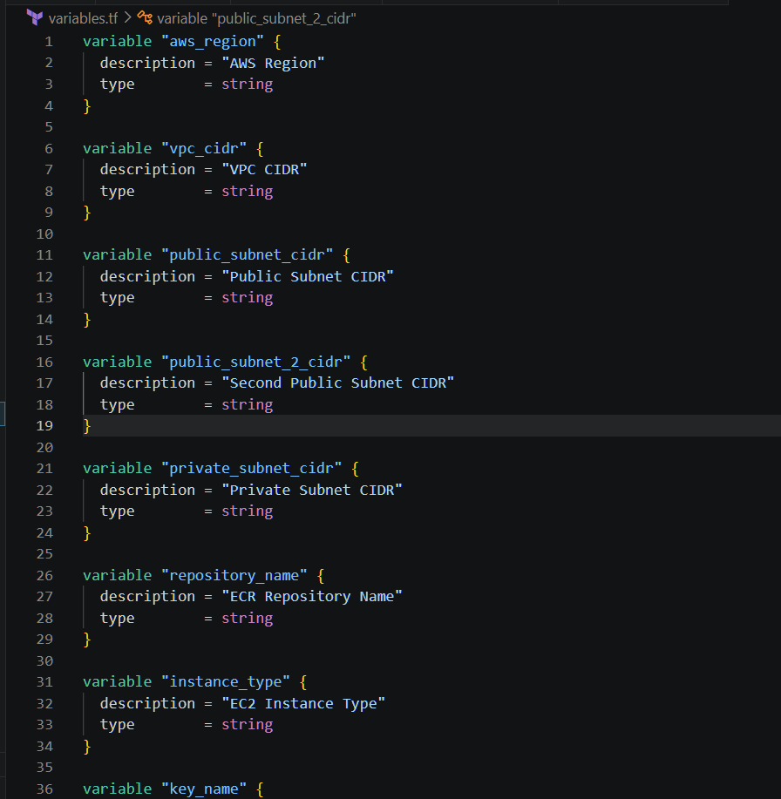
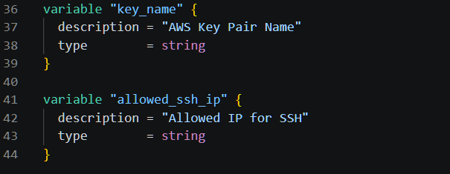
Created Providers.tf file
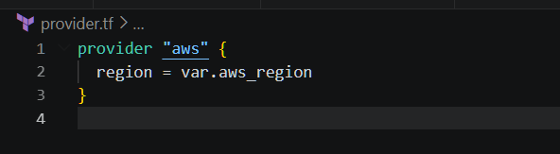
Created terraform.tfvars
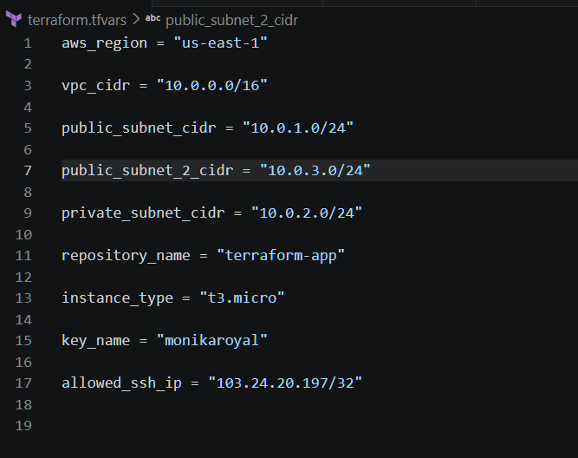

Created outputs.tf file
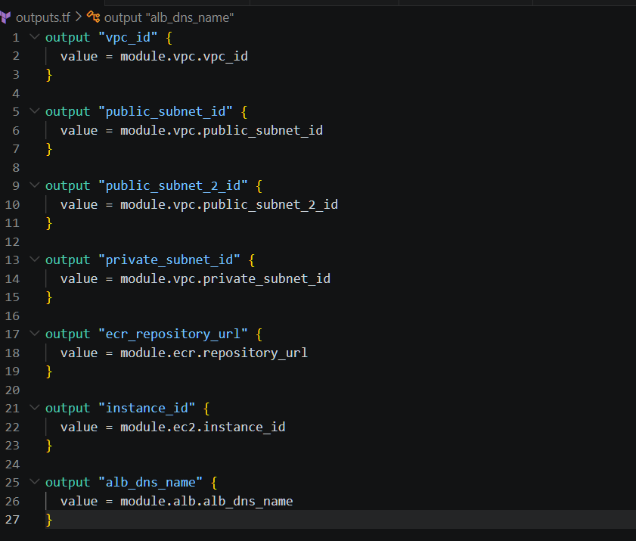

Index.html
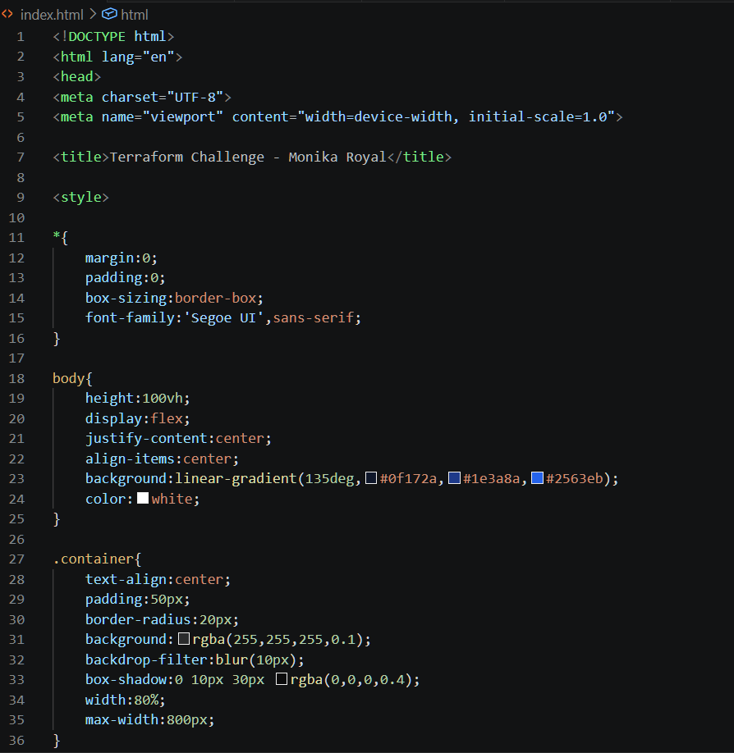
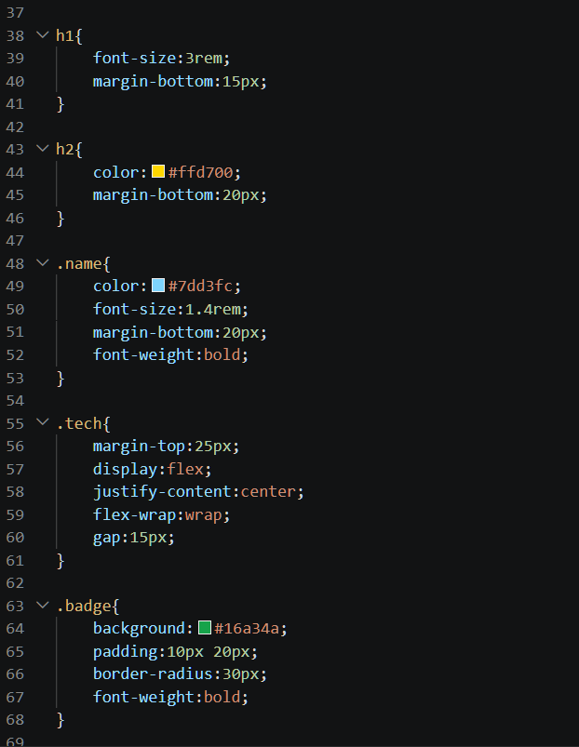
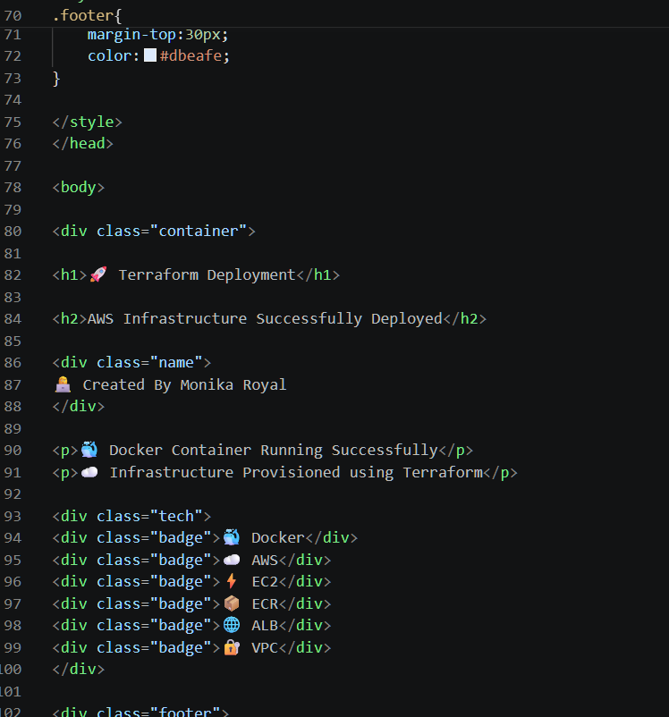
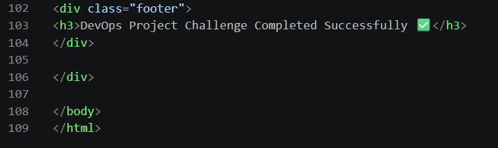

Dockerfile
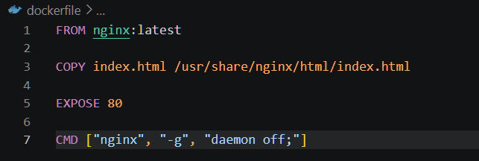

Next I have created a folder called modules and inside the folder I have created a ec2 folder
Ec2
Main.tf
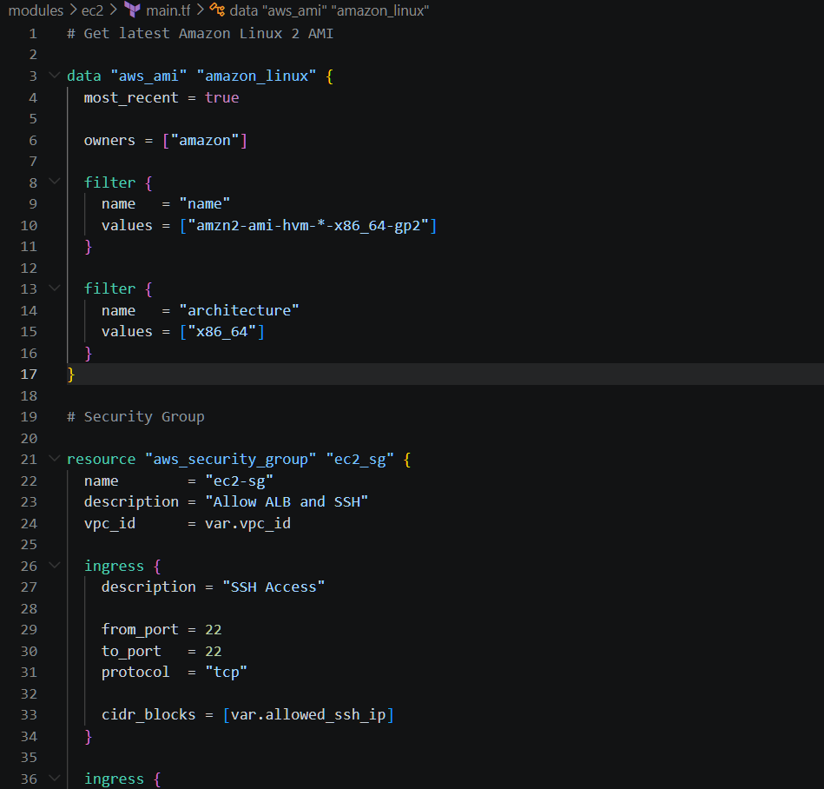
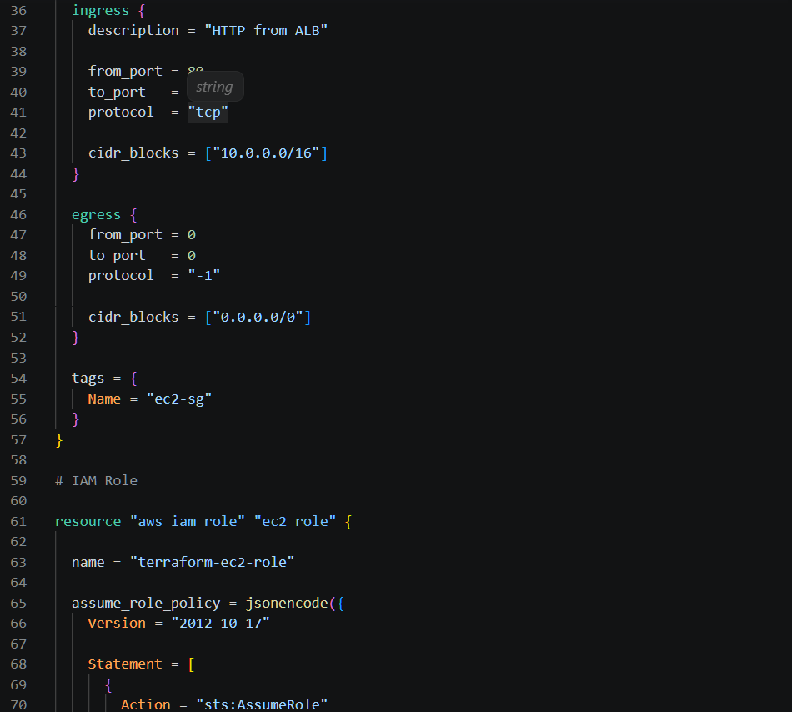
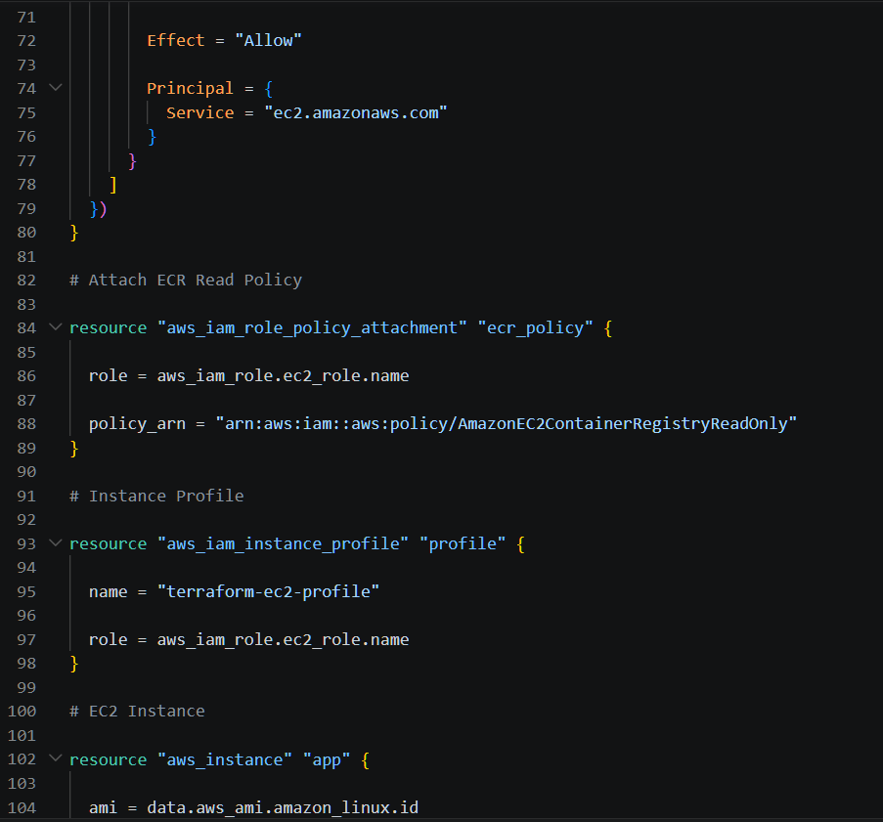
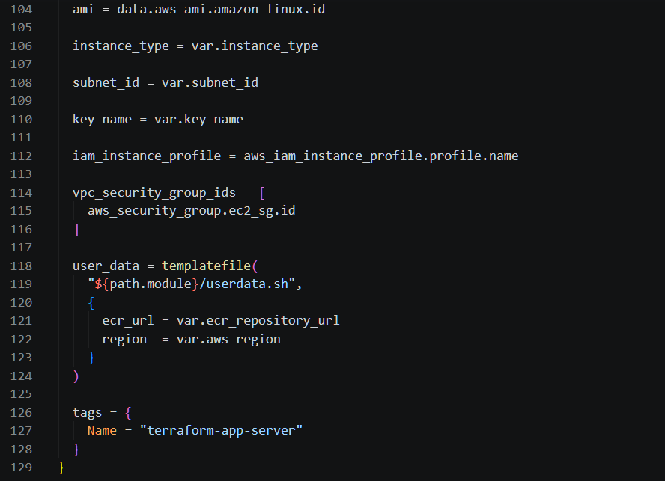
Output.tf
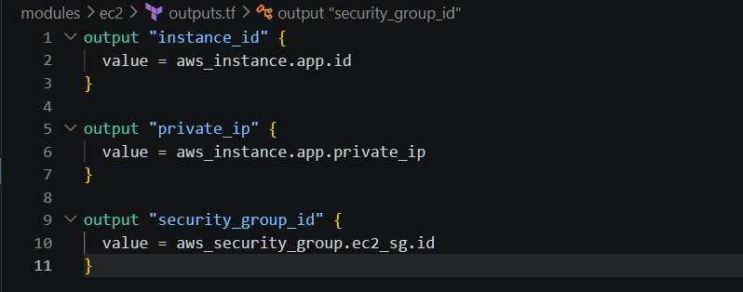

Userdata.sh
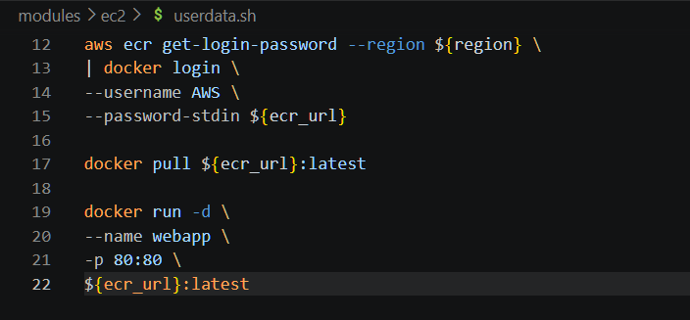
Variables.tf
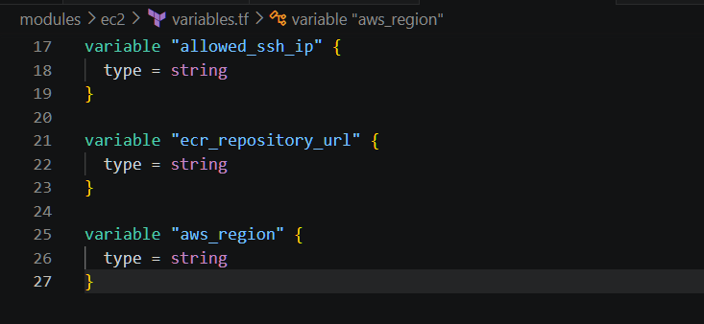

Created another folder inside modules VPC
VPC
Main.tf
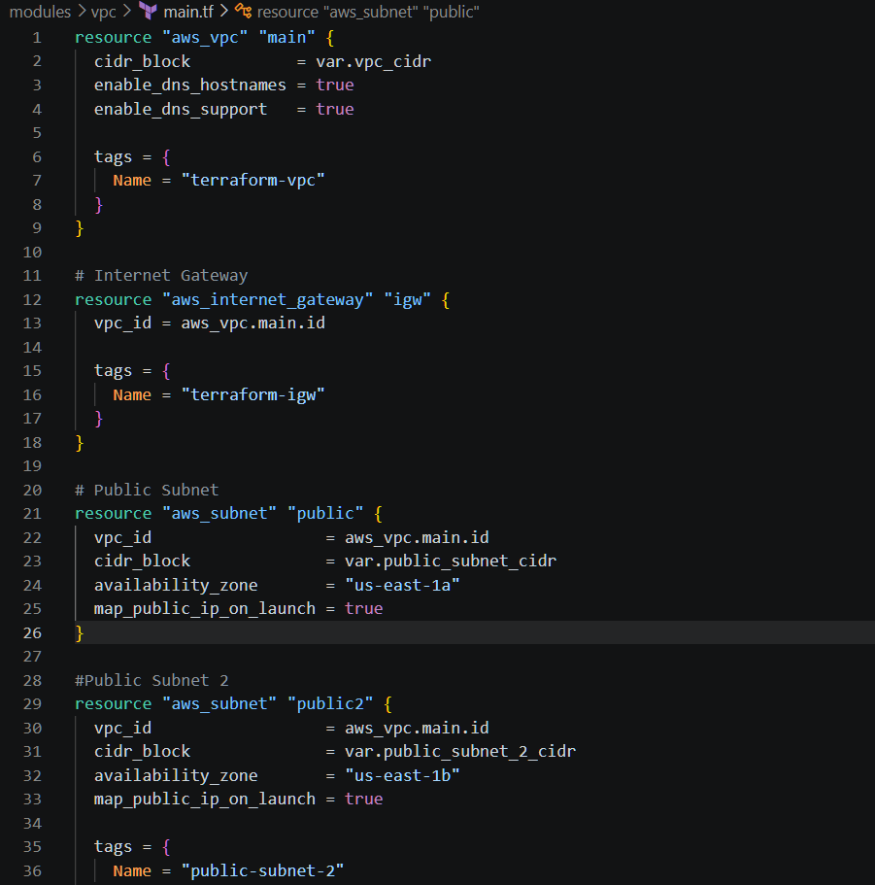
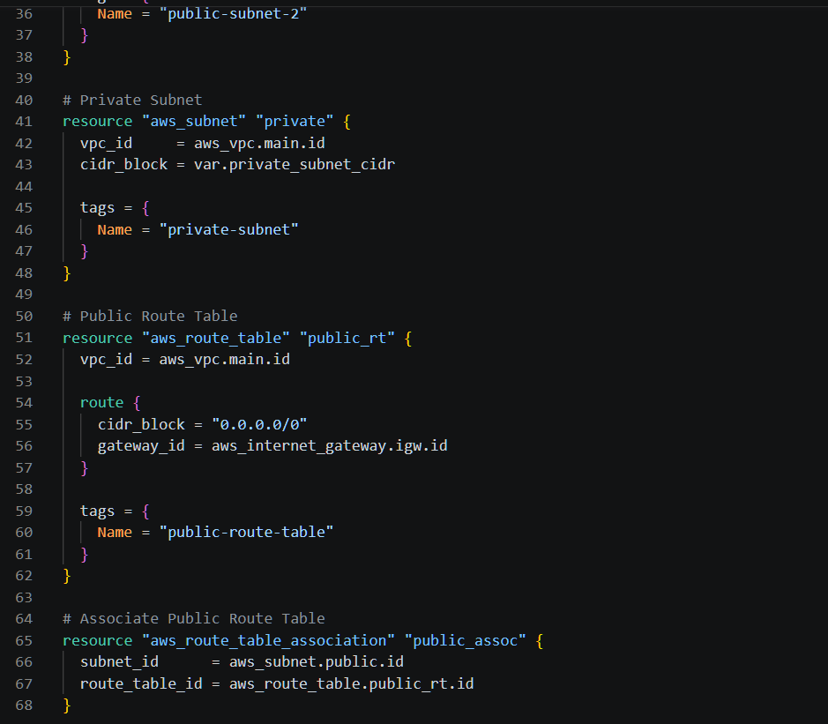
Outputs.tf
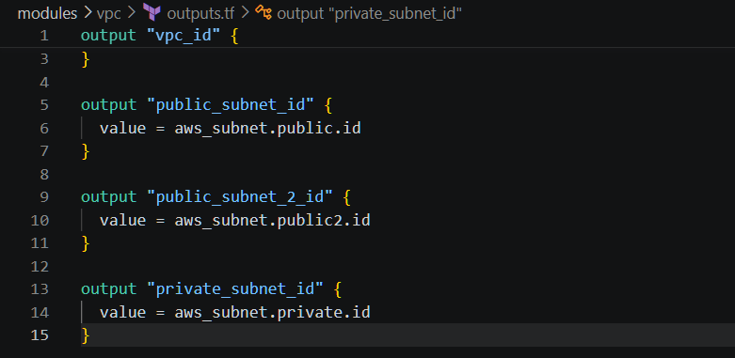

Variables.tf
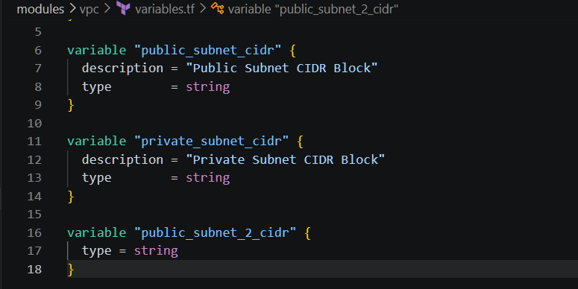
Inside modules I have created another folder called ECR
ECR
Main.tf
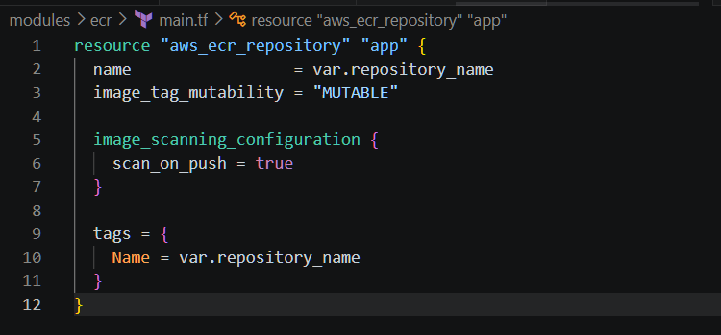

Output.tf
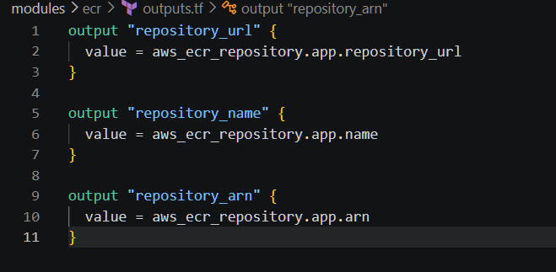
Variables.tf
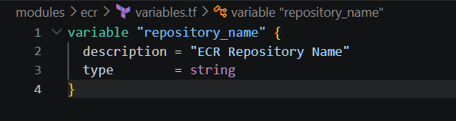

Inside modules I have created another folder called ALB
ALB
Main.tf
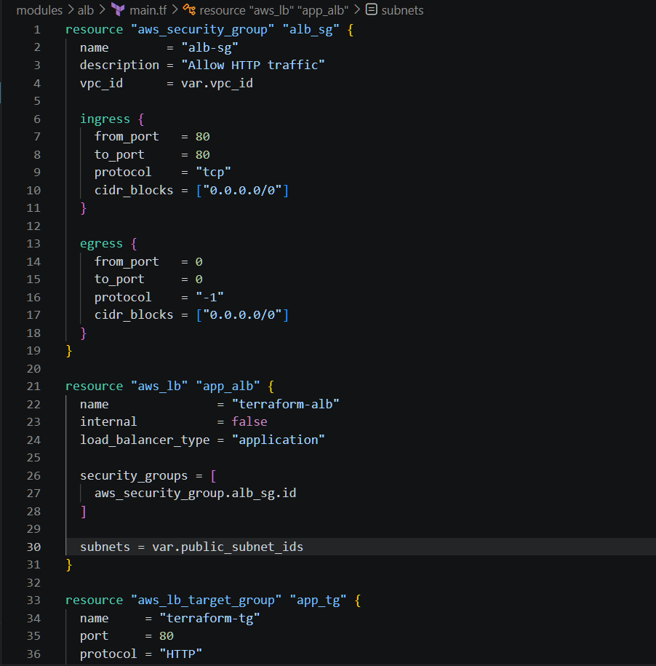
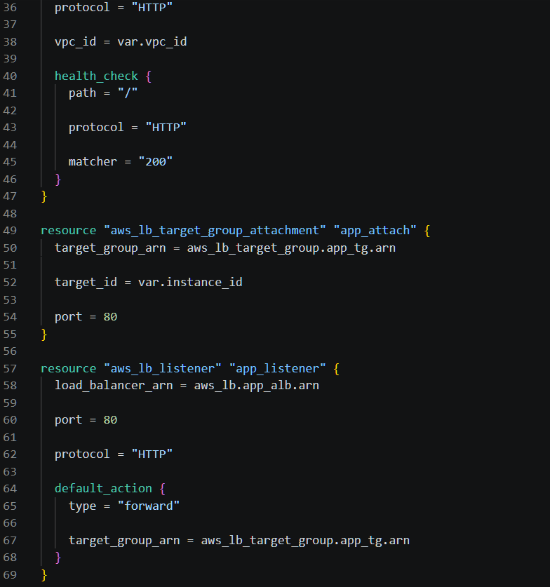
Outputs.tf
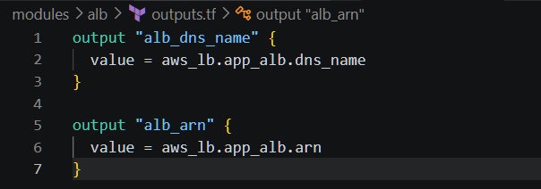
Variables.tf
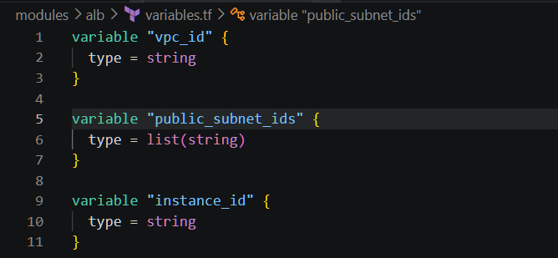
File structure

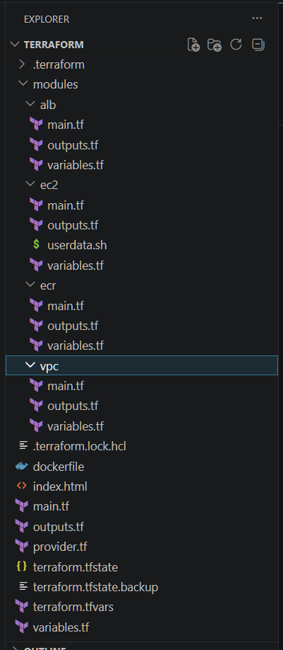
Performed
terraform init
terraform plan
terraform apply
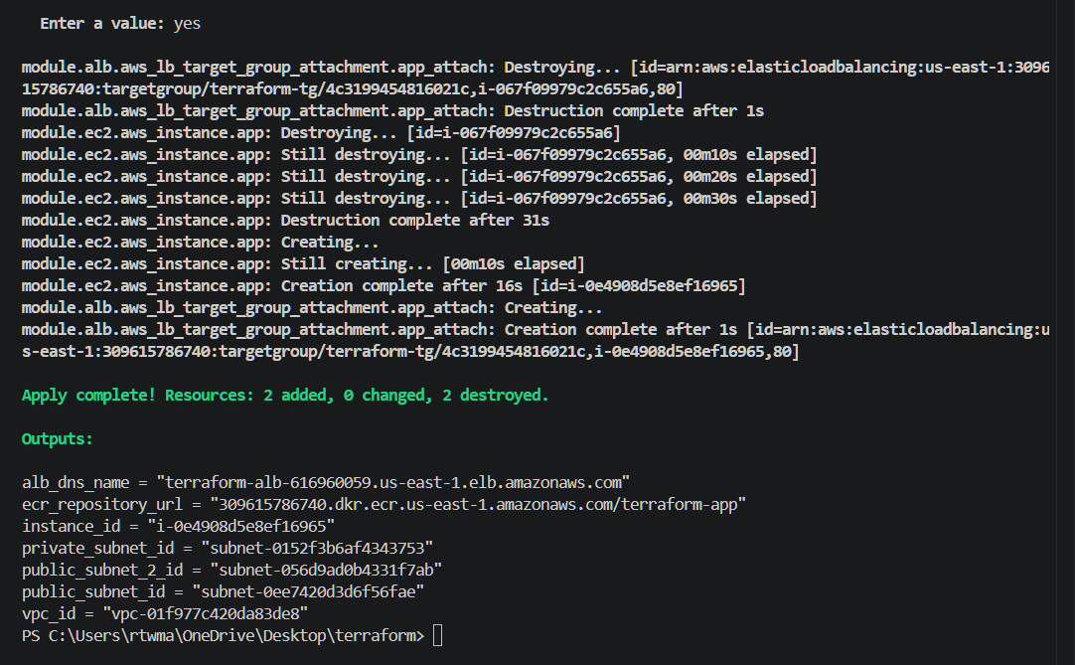
Download docker on desktop
docker build -t terraform-app .
docker tag terraform-app:latest 309615786740.dkr.ecr.us-east-1.amazonaws.com/terraform-app:latest
docker push 309615786740.dkr.ecr.us-east-1.amazonaws.com/terraform-app:latest
terraform apply -replace="module.ec2.aws_instance.app"

Pushed to docker
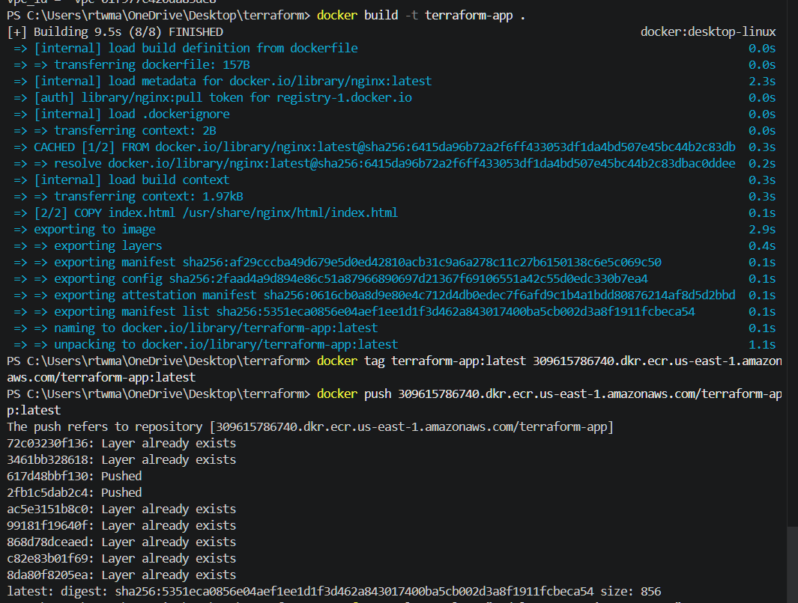
Then verified in the AWS
VPC
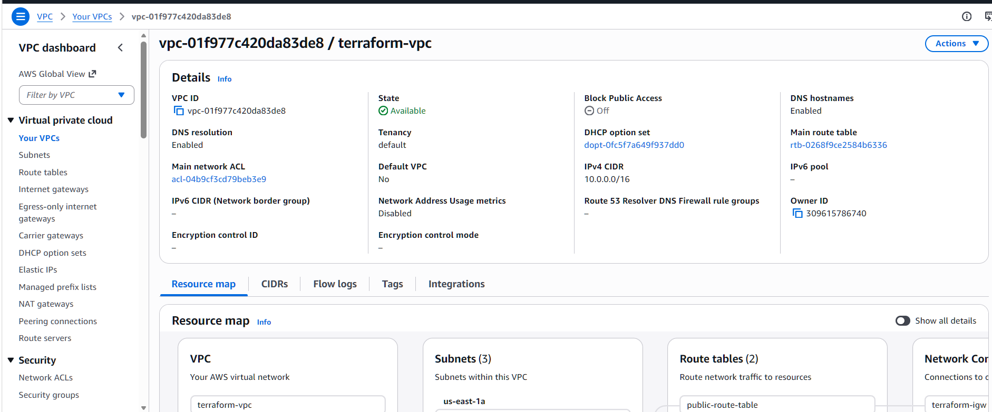

Subnets
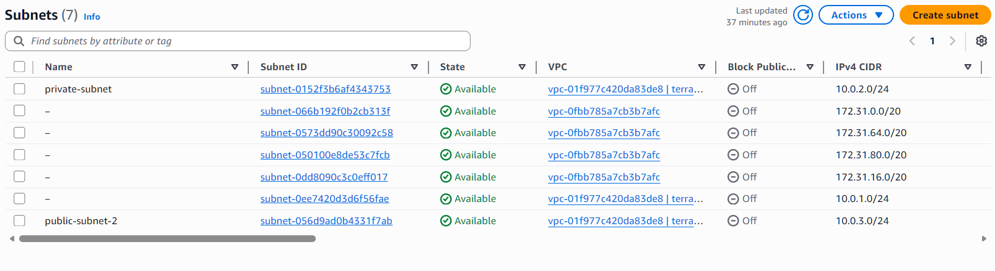
IGW is created
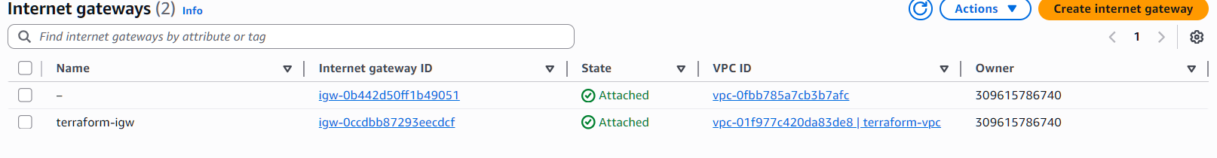
Security group is created
EC2 instance is created
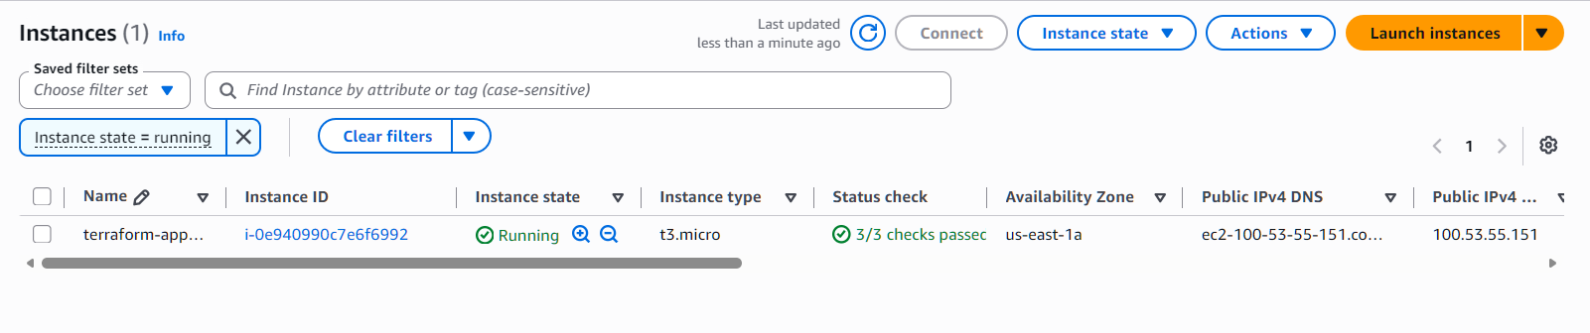
ECR is created and images are pushed
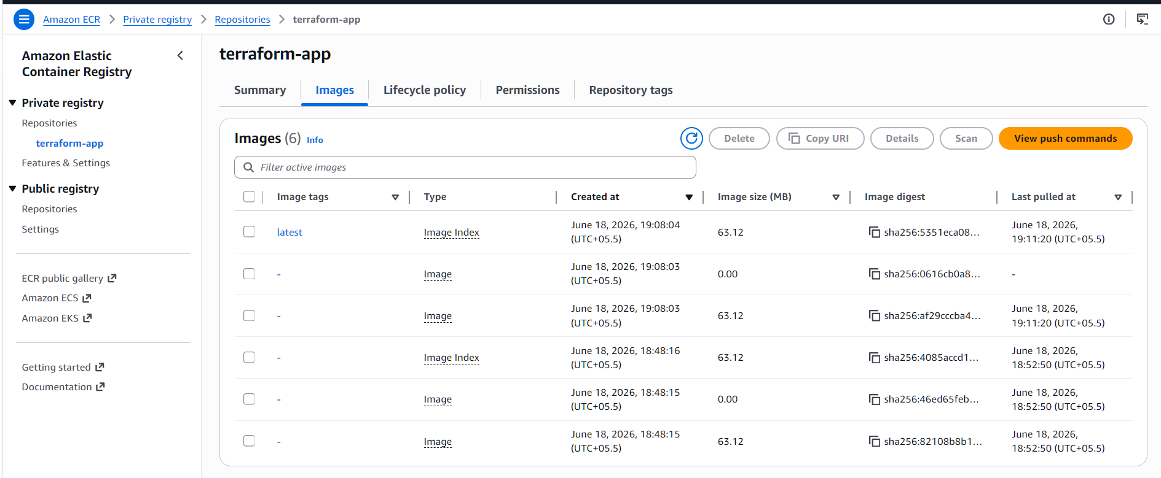

IAM role is created
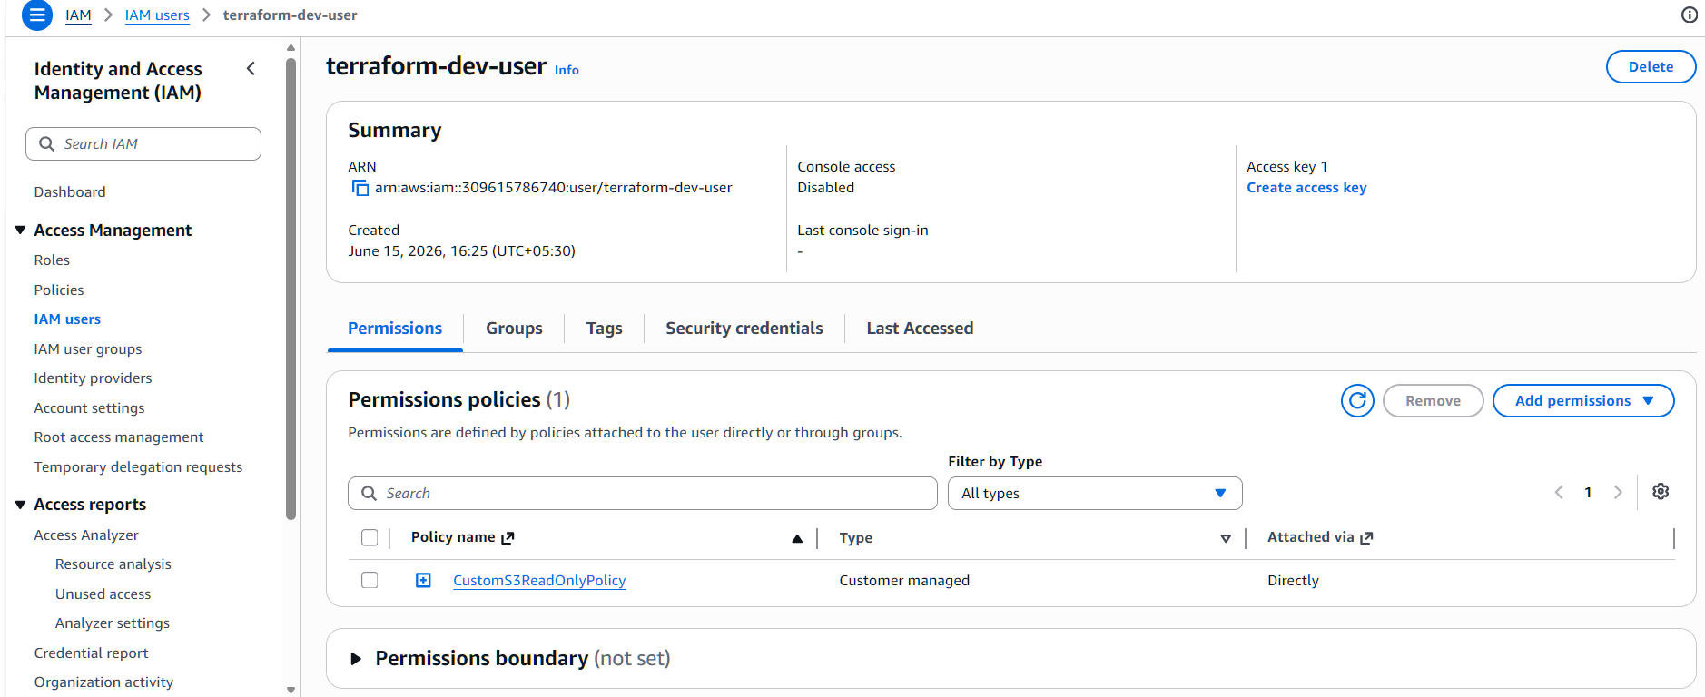
Target groups
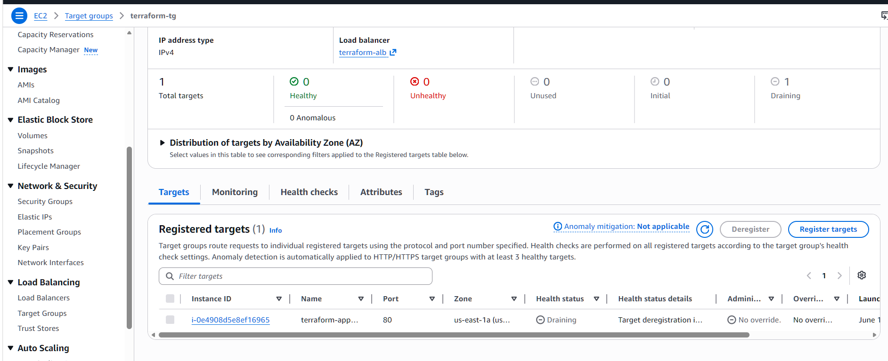
Load balancer is created successfully
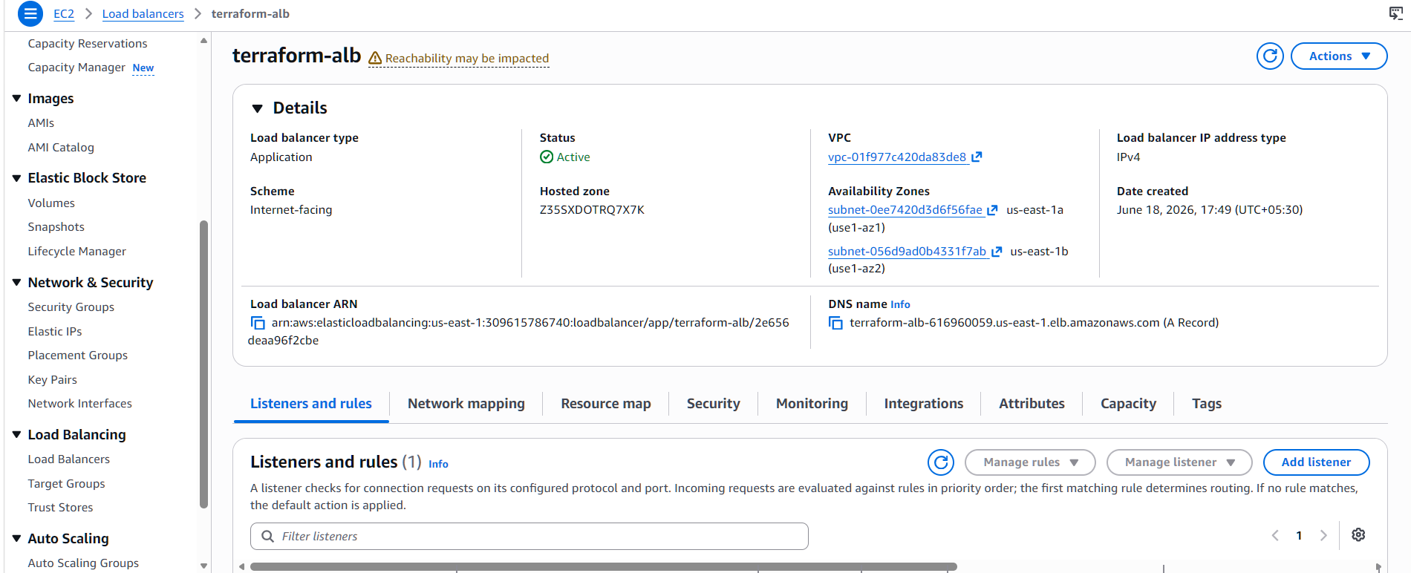

Route tables
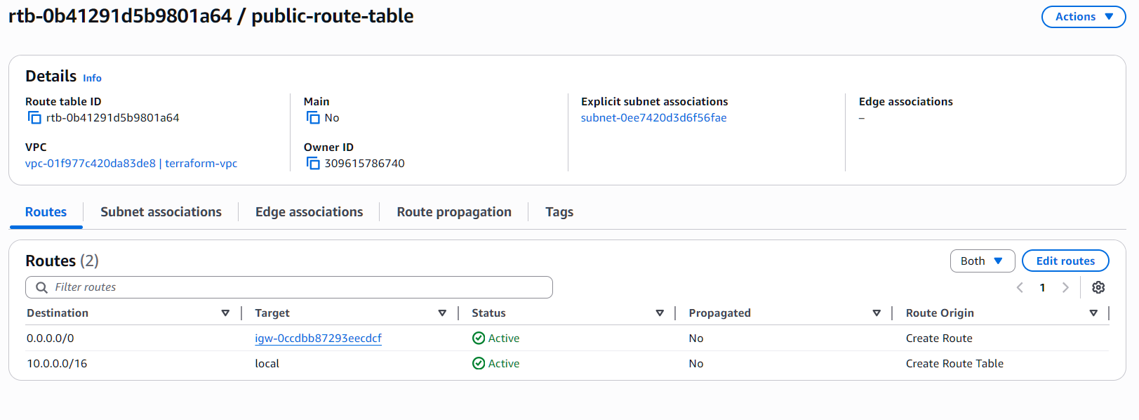
Index.html file is execute successfully with ALB DNS
